……….
30723 Sodaville Rd Lebanon, Oregon
August 2019 Volume 8, Issue 19

City Hall (541) 258-8882 Mayor Suzie Hibbert email: sodaville@cityofsodaville.org
Web Address: www.sodaville.org Judy Smith – City Administrator
000000000000…………..000000000000000000000000000000

City Council Meeting City Hall Hours
7:00 pm August 15, 2019 Mon. – Thurs. 10 am – 2 pm

CITY UPDATE
All Households should have received the Water Restriction Notice on July 29. As a reminder here is the information: Effective Immediately! HOUSEHOLD USE ONLY!!
The City of Sodaville Water Utility and the City of Sodaville City Council are placing water restrictions on outside watering. Water Restriction Rates will apply to bills as of 8/01/2019, enforcement is now in effect.
No outside water use includes:
- No watering of lawns.
- No sprinklers or underground drip systems.
- No filling of swimming pools.
- No washing of cars, decks, buildings, sidewalks etc.
- Watering of gardens will not be restricted
Due to this year’s lack of adequate rainfall and continued hot and dry conditions the City’s wells are at extremely low conditions and the rate of customer usage is greater than the City’s water production. This is a NO TOLERANCE ORDER. City Resolution #03-01 in accordance with Ordinance #15-02 allows the City of Sodaville Water Utility to impose a penalty for unauthorized use. This penalty is $500.00 per offence plus water used and will be enforced.

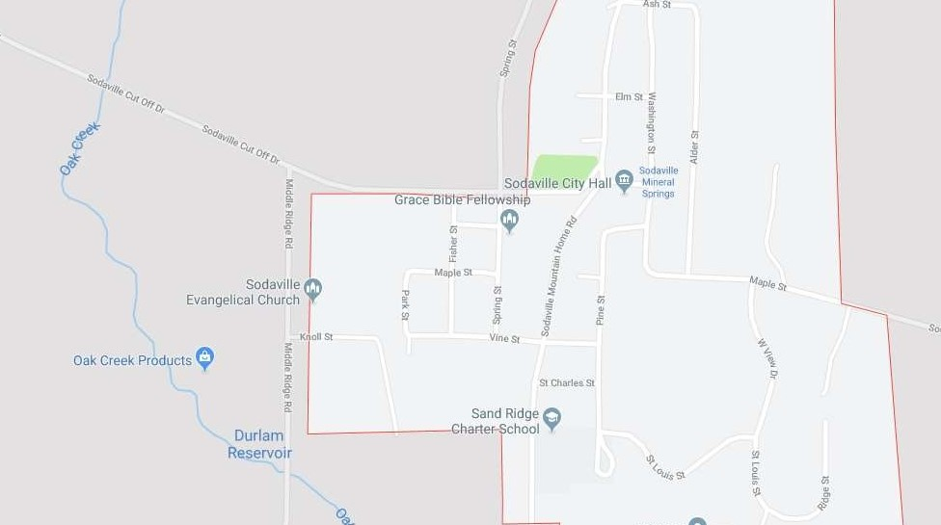
Sodaville History:
Oak Creek featured in Sodaville history as a source of power. Old timers tell of a furniture shop located in the northwest corner of the J.J. Sims place. Here, in pioneer days, was once a brick yard. Not many years ago, brick bats could be seen scattered about. A little farther upstream are two small ravines that had been dug in the side hill for wheel pits. The wheel pits were for the water wheel that generated power for the factory. This is the site for the old Baily Furniture Factory (1860), the Edwards Wagon Shop (in the same building as Baily) and the McKinney Sawmill (1865). The water wheel that furnished power for them was set in the ravines, or wheel pits, and water brought to them in the wooden flumes from the mill race on the hill above.

Judy Smith, City Administrator

MAYOR’S MESSAGE
Feel the heat of August? Feel the dryness in the air? The wells are feeling dry also. We are hauling in water already which means restrictions… don’t forget, it’s a No Tolerance Ordinance meaning you use the water outside you pay the fine. It’s just not ok right now. Gardens can be watered, but remember to water conservatively, spraying the hose at the dog while “watering the garden” does not fly.
The Park is still in need of hands. Please, Please come help, we had a few new faces this last weekend. Thank you, to the fresh help and to the dedicated citizens. I know you all have lives and are busy, so are we. Come join us at the Saturday work days or Thursday August 15th @6.15 and help plan the next move, landscaping. We have 2 months to finish this project. Grants are funny like that, finish by the deadlines or no payments. Watch the Sodaville.org for posted work days. If you have a free couple of hours on a different day and want to pitch in, contact Stan. There are many things even around the city that if you can do, Stan can focus on other things. Be a part of the greater good!

Take care and see you around!

Suzie mayorhibbert@gmail.com

Public Works Newsletter
While reading meters each month I occasionally find a customer water leak. A notice is placed at the door notifying the customer of the leak. Most leaks are fixed in a timely manner after notification. During water restriction when a customer has a leak the leak must be fixed in a timely manner or the water will be shut off until repairs are made. In reality fixing the leak is less expensive than letting it leak and paying the high water bill. The cost of purchasing and hauling water from Lebanon is high and that cost is reflected on your bill with an active leak.

If you need help finding a leak I am available during working hours to help find it. Most leaks are fairly easy to find and fix. However, by law I cannot fix it for you. Homeowners can fix their own leaks if they are handy. If not a licensed plumber must be called. If you think you may have a leak it is easy to check. Make sure all water is turned off. Go to your meter box, open it up and look at the face of the meter. On the face there is a dial (looks like a gear on some and others are a triangle), if that dial is moving you have a leak.

Stan Smith, Public Works Director

Country Girl Quilting
*Long-arm Machine Quilting
Call Sharon Hill and Joleana Altom at 541-401-7936

Carries Country Inn Adult Foster Home
is located at 30785 Washington Street in Sodaville. “A safe, comfortable home
where you can keep your dignity, respect and independence.”
For information call: 541-570-1430

If you have any announcements, information or ads you wish to have published in the newsletter,
please call before the 6th of the month and I will be happy to insert them!

“The City of Sodaville is an equal opportunity provider and employer.”

